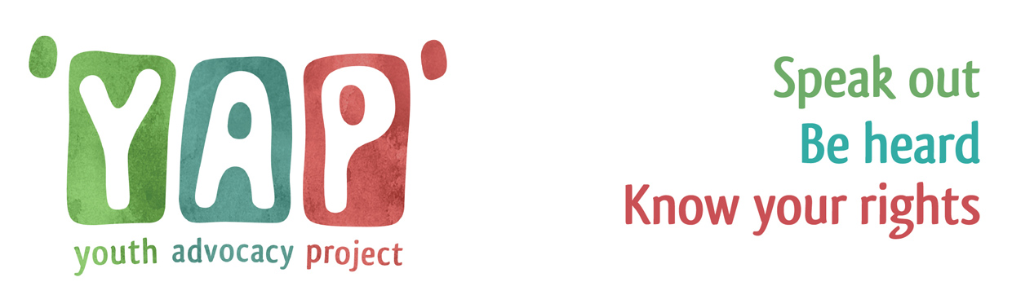**Referral Form**

**All about you and your family/carers**

|  |  |  |  |  |  |  |  |  |
| --- | --- | --- | --- | --- | --- | --- | --- | --- |
| **Name** |  | | | **Gender you identify with** | |  | | |
| **DOB/s** |  | | | **School you attend & contact** | |  | | |
| **Home address & Postcode** |  | | | | | | | |
| **Best way for us to contact you?**  **(Mobile number is best)** |  | | | **Do you consent to having an advocate?** | | | Choose an item. | |
| **Ethnicity** | Choose an item. | | | **Disability** | | | Choose an item. | |
| **Do you require an interpreter?** | Choose an item. | | | **If yes, what language?** | | |  | |
| **Do you have any important meetings coming up that you need an advocate to support you at?** | | | | | | | |  |
|  | | **Date** | **Time** | | **Location** | | |  |
| Initial Child Protection Conference | |  |  | |  | | |
| Review Children Protection Conference | |  |  | |  | | |
| Me & My World Review | |  |  | |  | | |
| Other state: | |  |  | |  | | |  |

|  |  |  |  |  |  |
| --- | --- | --- | --- | --- | --- |
| **Referrer Name** |  | Referrer Date | Click here to enter a date. | | |
| **Referrer’s Contact detail** |  | | | **Pod Number** |  |

**Who supports you?**

|  |  |  |  |
| --- | --- | --- | --- |
| **Who are the best people to contact who are involved in your care? E.g. Parent, social worker, IRO** | | | |
| **Role** | **Name** | **Contact details** | **Are you happy for us to contact these people?** |
|  |  |  |  |
|  |  |  |  |
|  |  |  |  |

**What would you like an advocate to do for you?**

|  |
| --- |
| **You have the right to the support from a Youth Advocate if you are - please pick which one applies to you** |
| Choose an item. |

|  |  |  |  |  |  |
| --- | --- | --- | --- | --- | --- |
| **What would you like to get from having an advocate? (please select ‘yes’ to as many as you want or add something in the box below that’s not here)** | | | | | |
| 1. | To make sure your views, wishes, opinions and feelings are listened to | Choose an item. | 6. | See more or less of someone | Choose an item. |
| 2. | Your views and feelings are passed onto the people supporting you | Choose an item. | 7. | Get your personal belongings back | Choose an item. |
| 3. | Tell people you are unhappy about something/make a complaint | Choose an item. | 8. | Try to get a decision made in your favour | Choose an item. |
| 4. | Over time to become confident enough to speak/advocate for yourself | Choose an item. | 9. | Feel happier about what’s going on in your life | Choose an item. |
| 5. | Request to change something like your social worker/PA, place to live or carer | Choose an item. | 10. | Ensure your cultural and religious needs and/or your identity/sense of self are understood and respected | Choose an item. |

|  |
| --- |
| **Are there any other important things you want to tell us…** |
|  |

|  |  |  |  |
| --- | --- | --- | --- |
| **Young Person’s Name:** |  | **Date** |  |
| **Signature:** |  | | |

Thank you for filling in this form. Please email it to [help@bhyap.org.uk](mailto:help@bhyap.org.uk). We’ll aim to contact you within five working days.

Advocates provide an open service – ensuring that no information they have or action they take is hidden from the young person. This includes the information that you give us on this referral form.